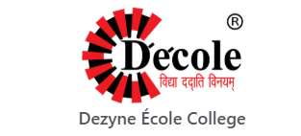
Hackthon Identity 2026
Project – Ajmer Goes live
Topic – Energy Gym By Ishant

Submitted by :- Purvi Khinchi
BCA Batch – A
Semester – 1st

PROCESS SHEET
1. Client Details
- Service Name – Energy Gym by Ishant
- Business Type - GYM
- Director’s Name – Mr. Ishant
- Website Purpose: To provide information about the gym, its items facility, faculty, and contact details.
- Client Requirements:
  - Information about the GYM.
  - Knowledge about different machines .
  - Faculty details.
  - Contact information.
  - About fees structure.

2. 5 questions you asked and their answers!
Question 1: What is the main reason you want this website?
Answer-We want an online identity of GYM. It will make it easy for Clients to check about our Services.
Question 2: What pages and information do you want on the website?
Answer-The website should clearly show an introduction about Services.
Question 3: How do you want Clients to contact you through the website?
Answer-We need our phone number and address listed clearly, along with a simple enquiry section where Clients can check for message us through whatsApp link.
Question 4: Do you have a logo or any specific colour preference for the design?
Answer-No ,we don’t have a specific logo. For colours, we prefer something darkish colour which looks clean.
Question 5: Do you want to show the gym fees on the website?
Answer- Yes, we want to show the fees structure.

3. Sitemap

- Email
- Location
- Opening Hours
- sese

- Train
- Generate
- Compete
- Pick how you train

- Our Story
- What We Do
- What We Stand For

- About GYM
About Page
Contact Us
Services
HOME PAGE
Sitemap Of My Crusher Parts Website
4. Hand-drawn Wireframing

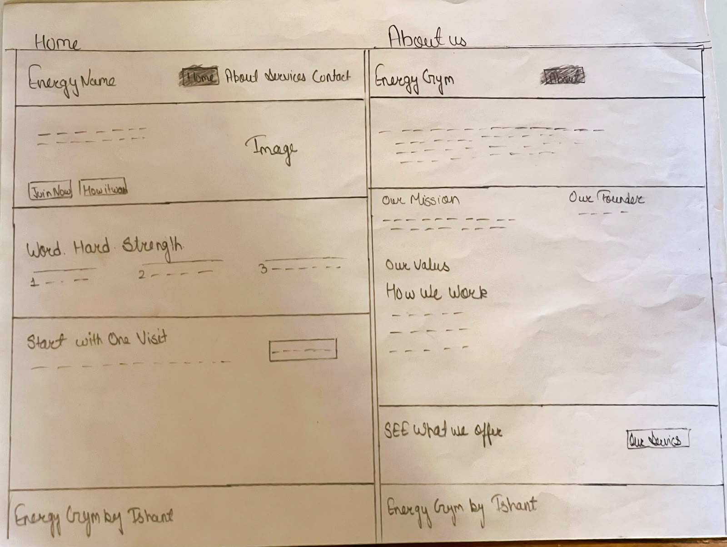

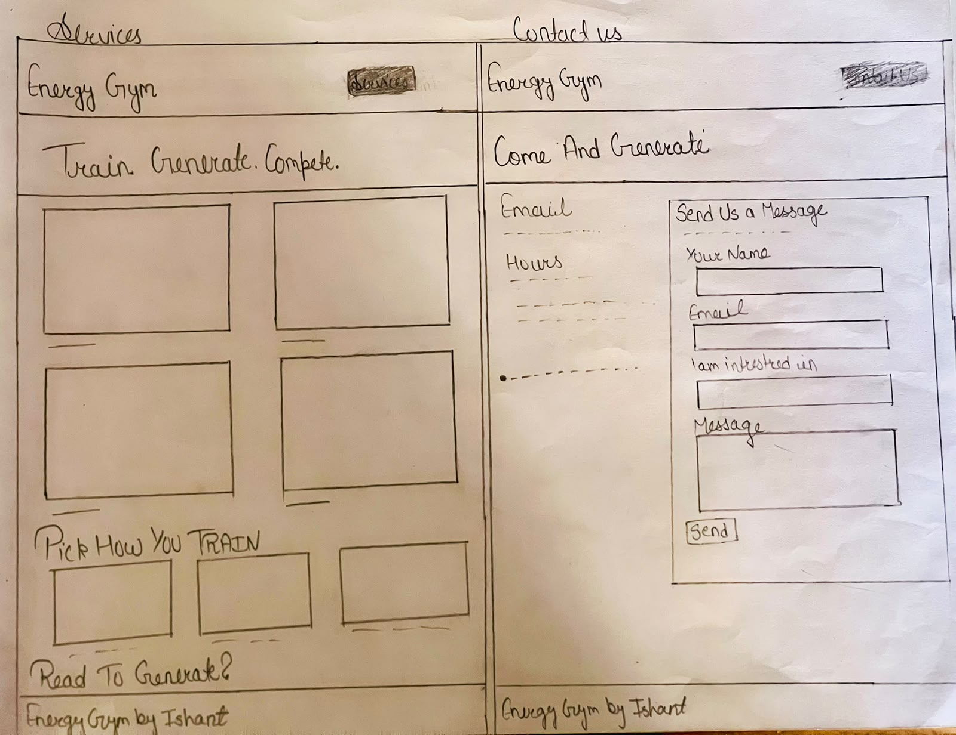

5. Reason for choosing colour and font style
1. Reason for Choosing the Color Combo (Blue and White)
- Direct Alignment with Heavy Industry: Deep charcoal/slate paired with vibrant rust-orange immediately evokes heavy machinery, mining, and quarry equipment (reminiscent of safety gear and brands like Caterpillar or Komatsu). Orange is universally associated with construction, high durability, and industrial safety.

- Maximum CTA Visibility: The warm, high-energy orange creates strong visual contrast against the dark background. This guides the user's eye directly to key conversion targets—specifically the primary call-to-action button ("View products") and the active navigation tab.

- Modern & Rugged Aesthetic: Rather than using a generic corporate white background, the deep slate dark mode gives the interface a solid, heavy-duty feel that reflects the strength and longevity of wear parts like concaves and jaw plates.

- Palette Harmony with Photography: The warm orange accents seamlessly mirror the yellow-orange tones of the industrial crushing plant in your imagery, giving the entire interface visual balance and cohesion.
2. Reason for Choosing Font Style (Arial, Helvetica, sans-serif)
- Industrial Strength & Solid Presence
- High Contrast & Screen Legibility:
- Clear Visual Hierarchy
- Modern B2B Standar

6. Validator And Lighthouse Screenshots
- Home Page
Validator :-
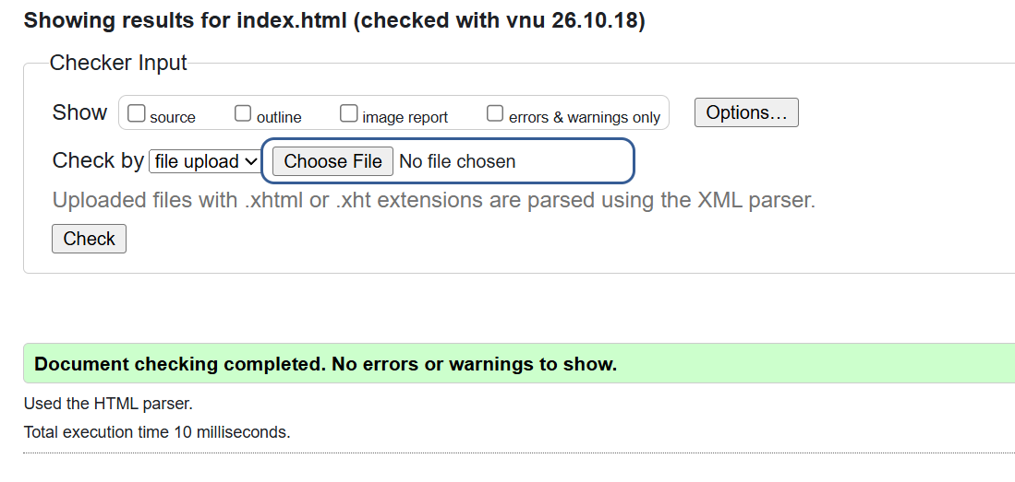

Lighthouse :-
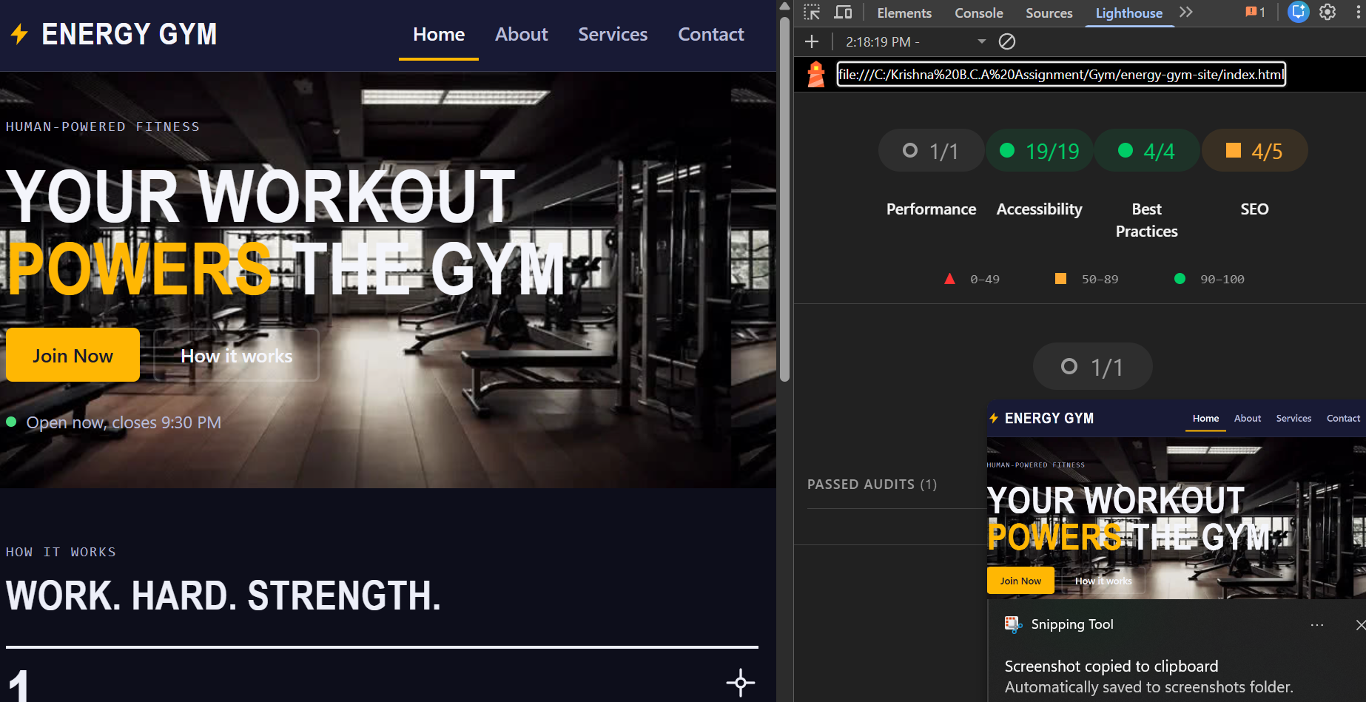

2.About Page
Validator :-
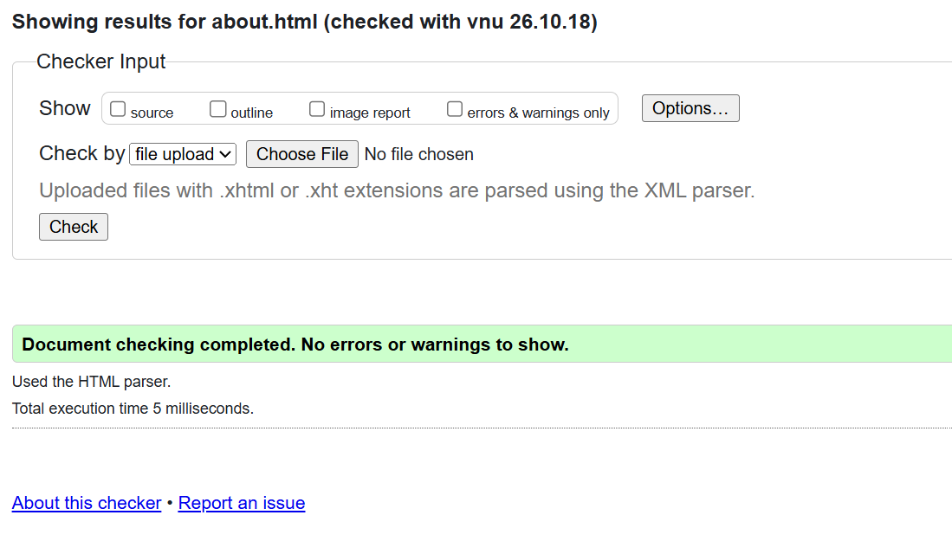

Lighthouse :-
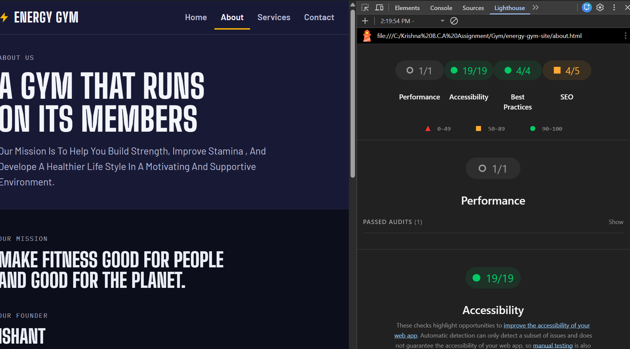

- Services
Validator :-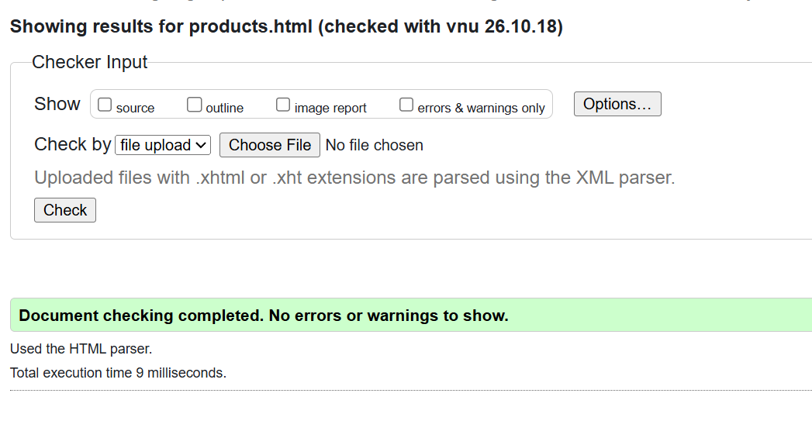
Lighthouse :-
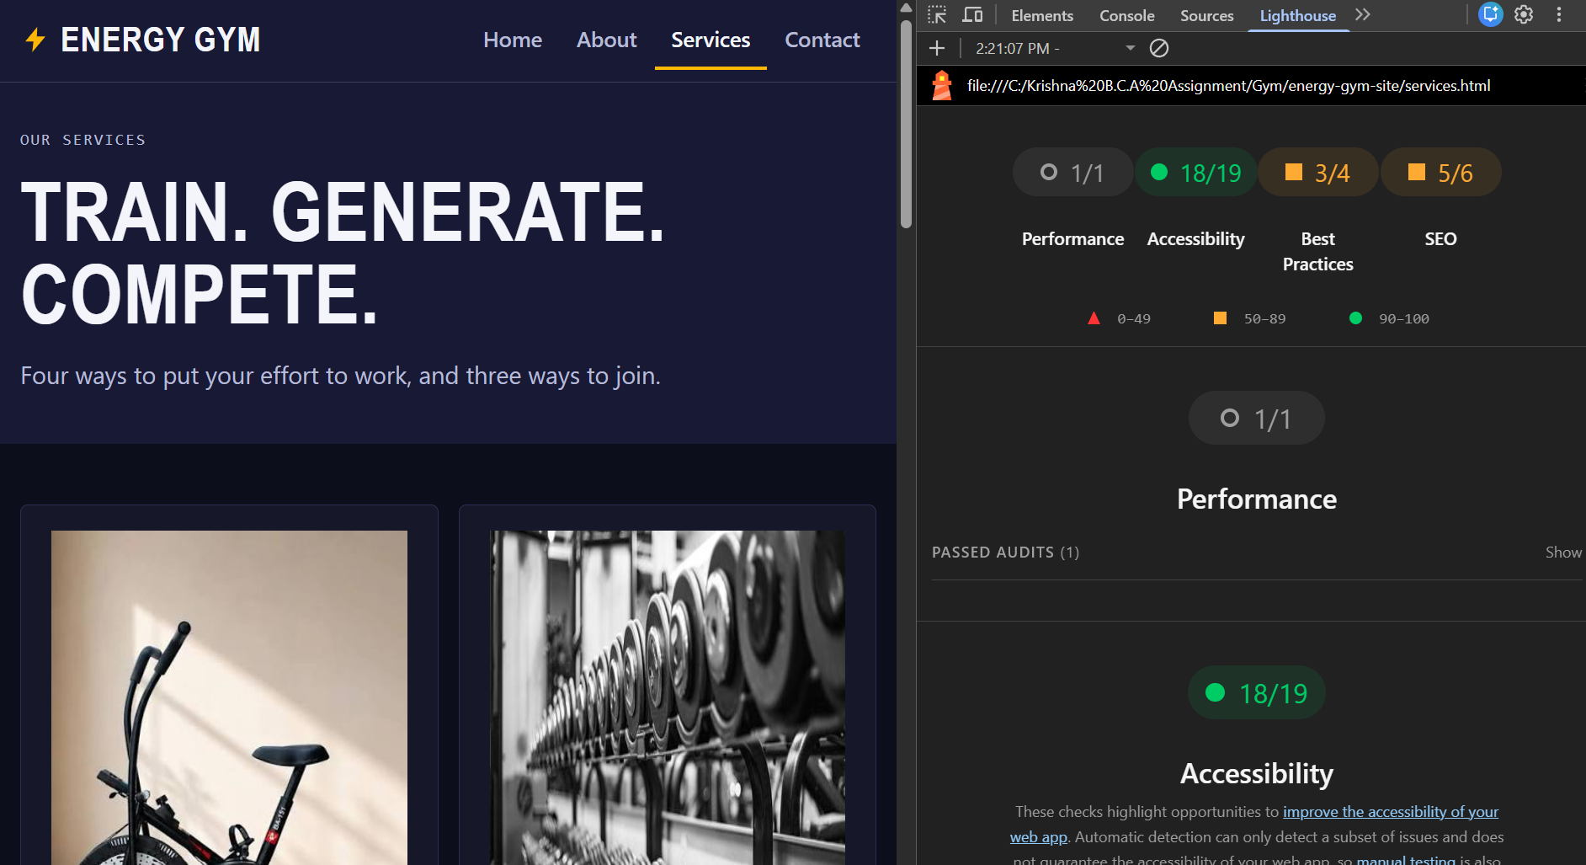

- Contact Us
Validator :-
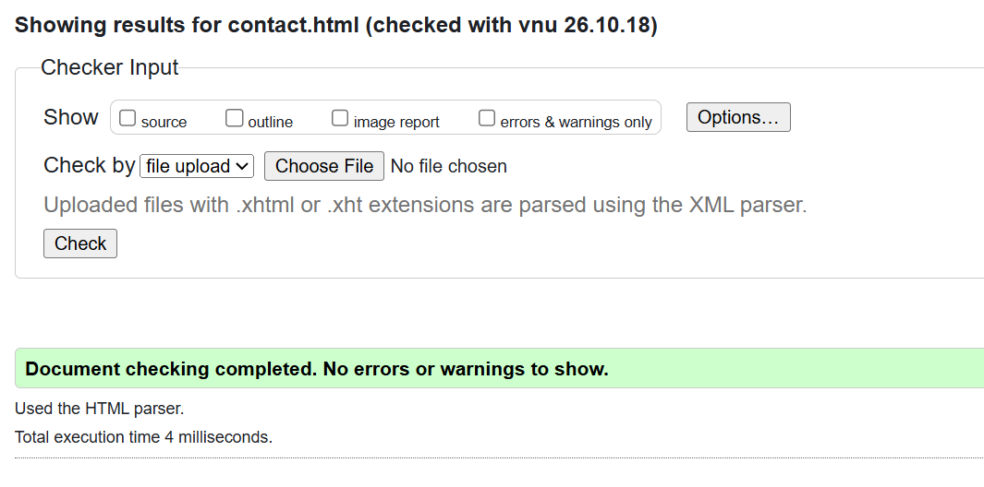
Lighthouse :-
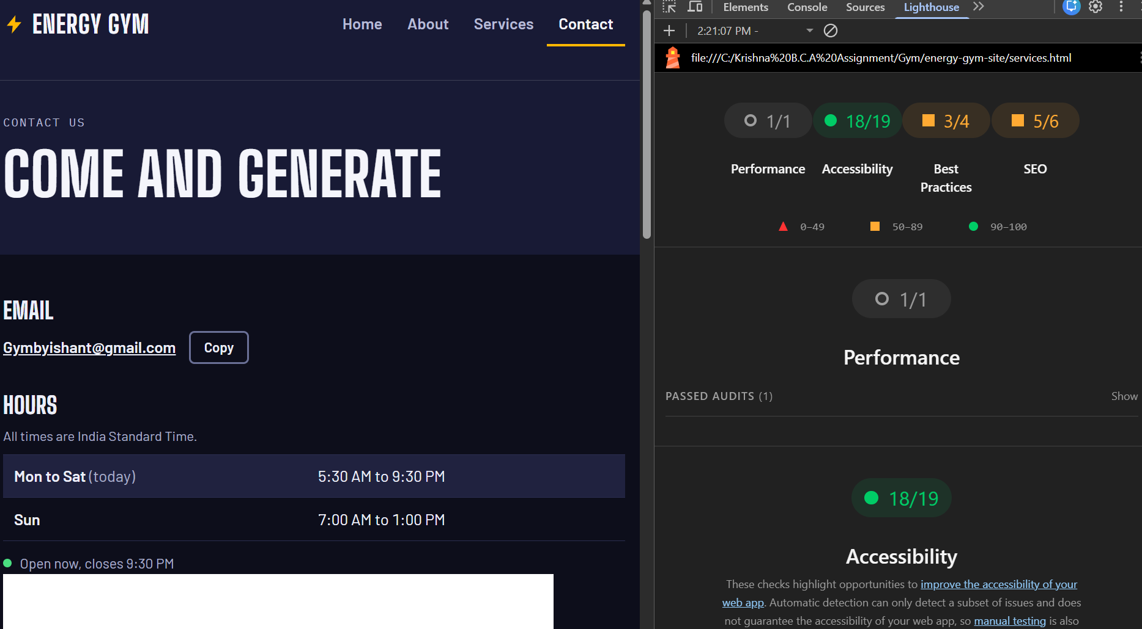

- STYLE SECTION
Validator :-
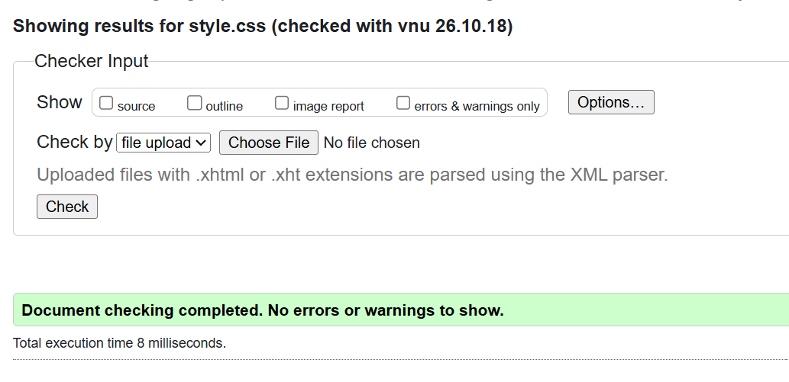

- Approval by client
